Technical Specifications

Product Name: | Integrated glass laser cutting and splitting equipment
Product Model: | GLC1 1 - 3 00 - 3 00

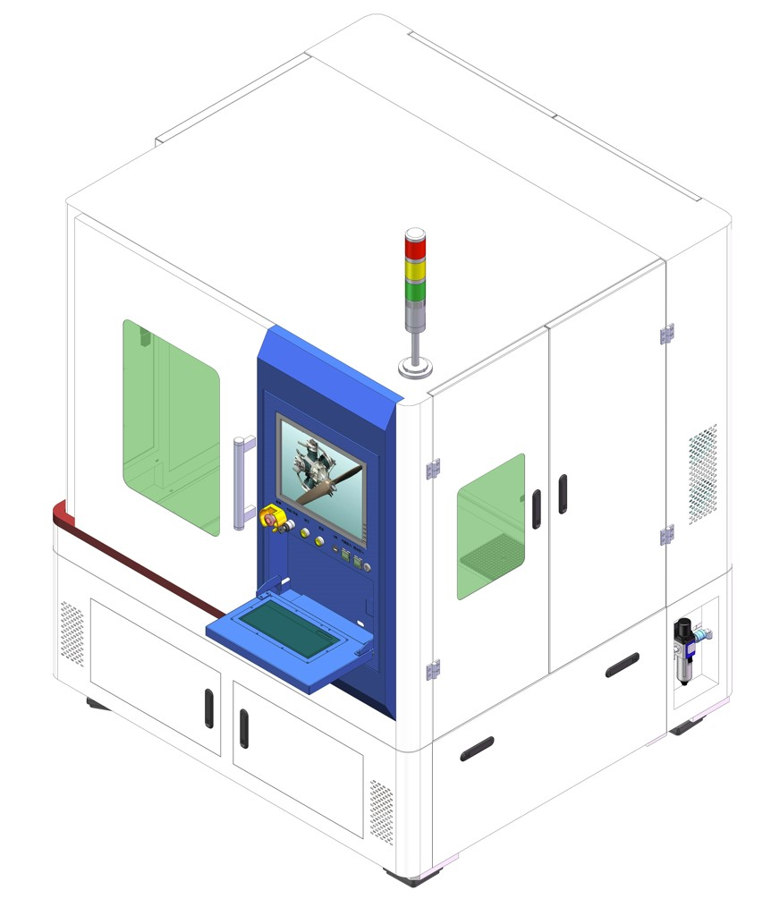

Lecheng Intelligent Technology (Suzhou) Co., Ltd.
January 2025

Table of contents
I. Equipment Overview 3
II. Processing Object 3
III. Specifications Overview 3
1. Technical Parameters 3
2. Processing diagram 4
3. Equipment Structure 4
4. Main components of the equipment 5
IV. Functions of Main Components 5
1. Laser 5
2. Imaging System 5
3. Movement mechanism 6
4. Electrical control system 6
5. Software System 7
V. Laser processing capability 7
VI. Factory Requirements 8
VII. Related Attachments 8
1. Documents and materials 8
VIII. Service Description 9
1. Installation and debugging 9
2. After-sales training 9
3. Equipment Maintenance 9

- Equipment Overview
This equipment is used for cutting and cleaving glass with a maximum size of 300x300mm . It highly integrates infrared picosecond laser and CO2 laser cleaving systems. The infrared picosecond laser and its optical path are used for cutting , while the CO2 laser and its optical path are used for cleaving . It also includes a precision multi-axis motion system, imaging system, dust collection system, electrical control system, and laser processing software, enabling high-precision laser cutting and cleaving of glass.
- Processing objects
The object being processed is glass , with the following specific specifications.
Glass / Module Specifications | numerical values
size | 300 × 300 mm
Material | Glass
thickness | < 10 mm
- Specifications Summary
  - Technical parameters
category | project | Specification
Appearance | External dimensions (length) × width × High) | 15 0 0mm × 1 5 00mm × 18 00mm
Appearance | color | RAL9016 ( Customized )
Platform | Compatible glass substrate size | 300 × 300 mm
Platform | Minimum compatible size | 5*5mm
Platform | Loading and unloading methods | Manual loading and unloading
Platform | Platform Height | 85 0 ± 50 mm
Optics | Laser 1 | 60W , Infrared Picosecond
Optics | Laser 2 | 100W, CO2
Optics | Infrared cutting head | Lecheng Customization
Optics | CO2 _{cutting} head | Lecheng Customization
Optics | Optical transmission system | 2 sets, customized by Lecheng
Imaging system | camera | Digital camera
Imaging system | Function | Image target capture
  - Processing diagram

- An infrared picosecond laser, paired with a glass cutting head, performs laser glass cutting according to a pre-set drawing.
- _{A} CO2 laser, paired with a dedicated cutting head, is used to cleave the material according to a pre-defined drawing (which is consistent with the cutting path).
The ultimate goal is to achieve high-precision glass segmentation according to the drawings.
  - Equipment Structure
The entire equipment consists of 6 functional components: an infrared cutting module, a CO2 dicing module, a motion axis system, a dust collection system, a vision system, and a processing software system.
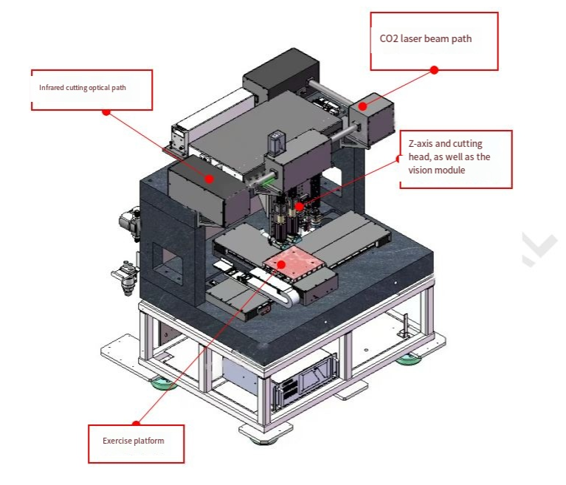

  - main components of the equipment
Serial Number | Accessories | quantity | Remark
1 | laser | 2 units | One set each of cutting and fracturing.
2 | Sports institutions | 1 set | X/Y/Z multi-axis motion system
3 | Laser cutting head | 2 sets | One set each of cutting and fracturing
4 | CCD imaging system | 1 set
5 | Optical transmission system | 2 sets | One set each of cutting and fracturing
6 | Electrical control system | 1 set | Equipment electrical control, including industrial PC
7 | Software control system | 1 set | Equipment control
8 | Mechanical structure and marble platform | 1 set | Welded steel structure + marble base
9 | Dust removal system | 1 set | Dust removal during laser processing
- Main component functions
  - laser
The equipment is equipped with two laser optical path systems: an infrared picosecond laser with a laser cutting head for glass cutting, and a CO2 _{laser} with a dedicated cutting head for glass sharding.
parameter | Technical parameters
model | Infrared picosecond laser | CO2 laser​​
Average power | ≥6 0W | > 100W
center wavelength | 1064nm | 10.6um
repetition frequency | 50 — 500 kHz​ | < 25kHz
Pulse width | < 15 ps​ | /
Energy stability | < 2 %rms over 8 hours | <±5%
Beam quality | M² ≤ 1.4​​ | M² < 1.3​​
Export spot size | 2.5±0.5mm | 1.8±0.2mm
Service life | >20000H | >20000H
model | TEM ₀₀ | continuous
Cooling method | Water cooling | air-cooled
  - Imaging system
The rangefinder CCD imaging system uses an image acquisition card and optical magnification lens to acquire target positioning marks for precise positioning and whole-piece processing. It features automatic recognition and target grabbing functions; simply place the material on the platform, and the equipment automatically loads it, locates the positioning marks, controls laser light output for processing, and automatically unloads the material after processing.
project | Wide angle
camera | Digital
Camera pixels | 5 million
lens | 1.5X optical magnification​
light source | LED light source
Camera field of view | ≥5.3mm*4.7mm
Mark type | Supports various commonly used Mark graphics
  - sports institutions
The equipment's axis system is an XYZ three-axis motion platform, independently developed and designed by Lecheng Intelligent.
The X axis is located on the upper marble of the gantry, moving along the X direction with the Z axis and the cutting module; the Y axis is installed on the base marble, moving along the Y direction with the processing platform. The Z axis enables precise control of the laser focus.
The platform features high speed, high precision, and good sealing. Its core components can be used for a lifetime, resulting in lower operating and maintenance costs.
The X and Y axes use linear motors, while the Z axis uses a lead screw structure.
project | Specification | Remark
X-axis linear mechanism | Processing area : 300 mm  of movement : >500 mm/s  Repeatability: ± 2 μm  Positioning accuracy: ± 2 μm | Effective processing range : 300 mm * 300 mm
Y-axis linear mechanism | Processing area: 300 mm  of movement : >500 mm/s  Repeatability: ± 2 μm  Positioning accuracy: ± 2 μm | Effective processing range : 300 mm * 300 mm
Z-axis focusing mechanism | stroke : 50mm  Maximum speed: 25mm/s | /
  - Electrical control system
The main electrical control section of the equipment consists of an industrial computer system, a motion control system, an image control system, and an I/O function system. The industrial computer system is mainly used for interface operation and upper-level logic operations; the motion control system is mainly used for motion trajectory implementation; the image control system is mainly used for product positioning and identification; and the I/O function system is mainly used to implement the status display of the three-color lights, and to turn functions such as blowing and adsorption on or off.
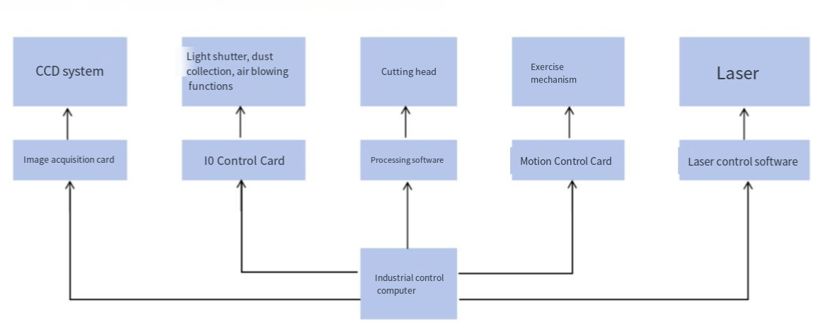

  - Software System
The equipment software is independently developed by Lecheng Intelligent. Based on its strong equipment integration capabilities, the company can carry out various customized designs according to customer needs, provided that the hardware configuration meets the requirements.
The main functions of the software system include reading machining drawings and converting them into machine-readable instructions, defining various machining parameter ranges in conjunction with hardware, controlling equipment operation, and monitoring fault reporting.
The software has the following functions:
project | Function | Detailed description
Software System | Integrated control | Including motion platform control and laser on/off light
Software System | Image import function | Supports importing DXF format documents from CAD software.
Software System | Online graphic editing | The user interface has an editing window for processing graphics.
Software System | Process Expert Database | Enables editing, archiving, and importing of processing parameters.
Software System | Port monitoring | Real-time monitoring of internal port status
Software System | Error Diagnosis | Outputting corresponding codes when an anomaly is detected facilitates diagnosis.
Software System | Image recognition and precise positioning | CCD image recognition enables closed-loop precise positioning control.
Software System | Layered processing | Parameters such as laser power, frequency, and processing speed can be set in layers.
Software System | Graphical path planning | Path optimization can be performed based on different processing layers.
- Laser processing capabilities
project | parameter
Glass size | 3 00 mm × 3 00 mm ( max )
glass material | Ordinary glass (without dirt, scratches, etc. on the surface)
Cutting graphics | Cutting straight lines, diagonal lines, arcs, and other shapes
Processing speed | ≤500 mm /s
Fracturing speed | Maximum 100 mm/s
Processing width | Cutting size: 5 μm
Machining line width accuracy | ≤±5 um
Machining position accuracy | ≤±10 um
Dimensional accuracy | ≤± 30um
Cutting ability | <10 mm (thickness)
chipped edge size | 50~ 80um
Yield (edge chipping < 100µm) | 99%
Utilization rate | 99%
Mean Time Between Maintenance (MTBG) | ≤1 hour
Mean Time Between Failures (MTBF) | ≥200 hours
- Factory needs
power supply | Three-phase 380V AC , 50Hz, 20A
Compressed air | 0.6-0.8 MPa , quick coupling , 12mm diameter
Ambient temperature | Temperature range: 22~25℃, with temperature fluctuations within ±1℃/24HR.
Ambient humidity | The humidity should be maintained between 40% and 60% , with no condensation.
Cleanliness requirements | 100,000 level or better
Base plate load-bearing requirements | 75 0 kg/m² ^{or} more
Equipment size | 150 0mm (L) × 15 00mm (W) × 18 00mm ( H)
Equipment installation space | 3500mm × 3500mm × 3000mm​​
Equipment weight | Approximately 2000 kg​​​
Device power consumption | Rated power 6 kW
- Attachments
  - Documents
The following is a list of documents to be included with the equipment upon delivery:
Serial Number | Document Name | Quantity (portions)
1 | Packing list | 1
2 | Equipment Instruction Manual | 1
3 | Electrical control schematic diagram | 1
4 | Laser Operation and Maintenance Manual | 1
5 | Certificate of Conformity | 1
- Service Description
  - Installation and debugging
According to the contract, the company will safely transport the equipment to the user's designated installation location within the stipulated time and dispatch technical service engineers for on-site installation. Provided the user has the necessary spare parts for installation and commissioning, the technical service engineer will complete the installation and commissioning of the equipment within 7 working days for the user's use, ensuring a neat, clean, and orderly installation and commissioning site environment.
  - After-sales training
After the equipment is debugged, the company will provide no less than two days of technical training to the user operators until they can use the equipment normally. The main training content is as follows:
1) Training on the use of commonly used drawing software;
2) Training on the use of laser processing software;
3) Training on start-up and shutdown operation procedures;
4) Training on the meaning of panel and software control parameters and the range of parameter selection;
5) Basic cleaning and maintenance of the machine;
6) Troubleshooting common hardware failures;
7) Issues to be aware of during operation;
8) In addition, it provides users with relevant process support for the products they manufacture;
9) The company provides different levels of training for users, such as operators and engineers.
  - Equipment maintenance
From the date of equipment acceptance, Lecheng provides a 12-month free warranty for the entire machine and lifetime maintenance services.
During the warranty period, after-sales personnel will be dispatched to the customer's site every three months to inspect the equipment, provide basic maintenance, and offer relevant usage advice.
If equipment malfunctions and the after-sales response time is less than 24 hours within the warranty period , priority will be given to providing remote guidance to the user's engineering personnel via telephone, video, or other means as soon as possible. For emergency faults that the user's engineering personnel cannot resolve on-site, the company's maintenance personnel will arrive on-site within 72 hours to resolve the issue. For equipment maintenance outside the warranty period, the two parties will agree on a separate matter.

